





**Cisco Unified Communications Manager**

**Phone Inventory Report**

**Phone Inventory Report**

**As-Built Documentation for project**

October 22, 2019

**Document Information - Universal**

**Version Status**

|  |  |  |
| --- | --- | --- |
| **Release Number** | **Date** | **Reason for Version** |
| 1.0 | October 22, 2019 | Release |
|  |  |  |

**Client Information**

| **Prepared for:** | **Large Company Inc.** |
| --- | --- |
| Name: | H. Boss |
| Title: | CEO |
| Address: | Corporate Way |
| Telephone: | 1 (555) 56987424 |
| Email: | hboss@largecompany.com |

**Presenter Information**

| **Prepared by:** | **Config Reports Ltd.** |
| --- | --- |
| Name: | Jennifer SMITH |
| Title: | Ms. |
| Address: | 22 Main Street |
| Telephone: | 123456787 |
| Email: | JSmith@email.com |

**Table of Content**

1 Report Information 4

2 Phone Statistics 4

2.1 Table of Phone Statistics 4

2.2 Phone Registration Per Model 5

2.3 Registered Phones Per Model 6

2.4 Unregistered Phones Per Model 6

2.5 Total Registered and Unregistered Phones 6

2.6 Phone Models Per Device Pool 7

3 CSV Files 8

4 Excel File 9

5 Phones 10

5.1 Analog Phone 10

5.2 Cisco 7832 10

5.3 Cisco 7841 10

5.4 Cisco 7861 11

5.5 Cisco 7941 11

5.6 Cisco 7945 12

5.7 Cisco 7975 12

5.8 Cisco 8811 13

5.9 Cisco 8841 13

5.10 Cisco 8941 14

# 1 Report Information

|  |  |
| --- | --- |
| **Report Summary** | |
| Report Date | 22/10/2019 5:11:00 PM |
| Report generated for | Phone Inventory Report |
| Description | As-Built Documentation for project |
| **Server Info** | |
| CUCM version | 12.5.1.10000(22) |
| CUCM IP | 10.5.1.120 |
| **Report Settings** | |
| Visual Style | Blu Light.css |
| Filter |  |
| Template HTML | PhoneInventoryTemplate.htm |
| Template Word | Triangle_Blue-universal.doc |
| **Report Tool Info** | |
| Phone Inventory Tool version | 12.0.19 / 19 Oct 2019 |
| Phone Inventory License | Licensed [Prof all] |

# 2 Phone Statistics

## 2.1 Table of Phone Statistics

| **Phone Statistics** | | | | | | |
| --- | --- | --- | --- | --- | --- | --- |
| **Phone** | **CUCM Status** | | | **Retrieval Statistics** | | |
| **Model** | **Total** | **Registered** | **Not Registered** | **Attempted** | **Retrieved** | **Failed** |
| Analog Phone | 1 | 0 | 1 | 0 | 0 | 0 |
| Cisco 7832 | 1 | 1 | 0 | 1 | 1 | 0 |
| Cisco 7841 | 1 | 1 | 0 | 1 | 1 | 0 |
| Cisco 7861 | 1 | 1 | 0 | 1 | 1 | 0 |
| Cisco 7941 | 1 | 1 | 0 | 1 | 1 | 0 |
| Cisco 7945 | 2 | 1 | 1 | 1 | 1 | 0 |
| Cisco 7975 | 1 | 1 | 0 | 1 | 1 | 0 |
| Cisco 8811 | 1 | 1 | 0 | 1 | 1 | 0 |
| Cisco 8841 | 1 | 0 | 1 | 0 | 0 | 0 |
| Cisco 8941 | 1 | 0 | 1 | 0 | 0 | 0 |
| Total | 11 | 7 | 4 | 7 | 7 | 0 |

## 2.2 Phone Registration Per Model

This chart shows how many phones are registered and unregistered for each model.

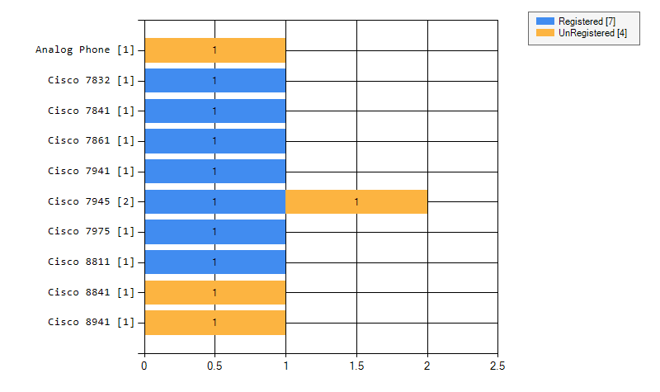

## 2.3 Registered Phones Per Model

This chart shows how many phones are registered for each model.

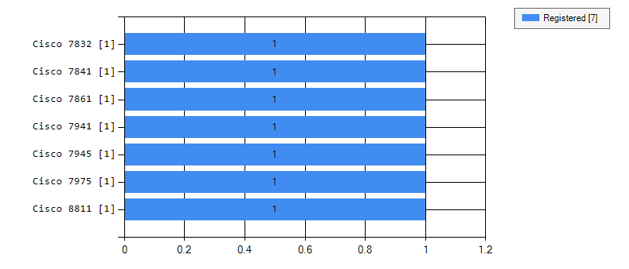

## 2.4 Unregistered Phones Per Model

This chart shows how many phones are unregistered for each model.

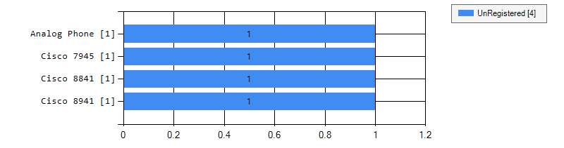

## 2.5 Total Registered and Unregistered Phones

This chart shows the total numbers of registered and unregistered phones.

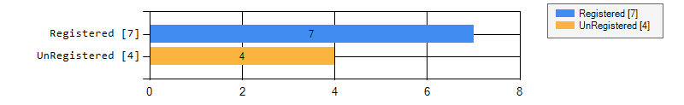

## 2.6 Phone Models Per Device Pool

This chart shows the total number of each phone model per device pool. It includes registered and unregistered phones. Each phone model is represented with a dedicated color.

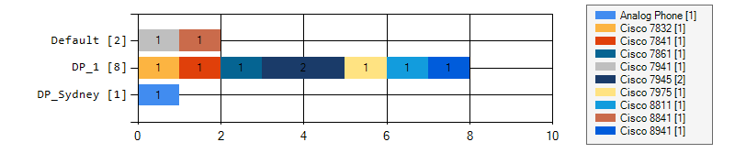

# 3 CSV Files

File: ..\csv\

Click here to open

# 4 Excel File

File: ..\xls\PHONEINVENTORY_Report_Phone Inventory Report.xlsm

Click here to open

# 5 Phones

## 5.1 Analog Phone

| **Analog Phone** | | | | | | | | | | | | | | | | | | | | | | | | | | | | | | | | | | |
| --- | --- | --- | --- | --- | --- | --- | --- | --- | --- | --- | --- | --- | --- | --- | --- | --- | --- | --- | --- | --- | --- | --- | --- | --- | --- | --- | --- | --- | --- | --- | --- | --- | --- | --- |
| **Name** | **Model** | **Protocol** | **Device Pool** | **Location** | **Description** | **1st Extension** | **1st_Extension Linetext** | **1st_Extension Display** | **IP** | **Active Load ID** | **Inactive Load ID** | **CCM registered** | **Timestamp** | **LoginUserID** | **Registration** | **Status** | **Serial Number** | **System Load ID** | **Hardware Revision** | **Software Version** | **MWI** | **Owner User ID** | **Mobility User ID** | **Neighbor DeviceID** | **Neighbor IP** | **Neighbor Port** | **PC Port Speed** | **Network Port Speed** | **KEM1 Product** | **KEM1 Serial** | **KEM1 Version** | **KEM2 Product** | **KEM2 Serial** | **KEM2 Version** |
| AN1234123410400 | Analog Phone | SCCP | DP_Sydney | Hub_None | AN1234123410400 | 999900 |  |  |  |  |  |  |  |  |  | Not available |  |  |  |  |  |  |  |  |  |  |  |  |  |  |  |  |  |  |

## 5.2 Cisco 7832

| **Cisco 7832** | | | | | | | | | | | | | | | | | | | | | | | | | | | | | | | | | | |
| --- | --- | --- | --- | --- | --- | --- | --- | --- | --- | --- | --- | --- | --- | --- | --- | --- | --- | --- | --- | --- | --- | --- | --- | --- | --- | --- | --- | --- | --- | --- | --- | --- | --- | --- |
| **Name** | **Model** | **Protocol** | **Device Pool** | **Location** | **Description** | **1st Extension** | **1st_Extension Linetext** | **1st_Extension Display** | **IP** | **Active Load ID** | **Inactive Load ID** | **CCM registered** | **Timestamp** | **LoginUserID** | **Registration** | **Status** | **Serial Number** | **System Load ID** | **Hardware Revision** | **Software Version** | **MWI** | **Owner User ID** | **Mobility User ID** | **Neighbor DeviceID** | **Neighbor IP** | **Neighbor Port** | **PC Port Speed** | **Network Port Speed** | **KEM1 Product** | **KEM1 Serial** | **KEM1 Version** | **KEM2 Product** | **KEM2 Serial** | **KEM2 Version** |
| SEP00727849DA40 | Cisco 7832 | SIP | DP_1 | Hub_None | Auto 10006 | 783201 | 7832 on 120 new | The 7832 conference phone | 10.5.1.58 | sip7832.12-1-1-12 | sip7832.12-5-1MN-490 | 10.5.1.120 | 22/10/2019 7:09:39 AM |  | Registered | ok | FCH2210DYHU |  | 01 | rootfs7832.12-1-1-12 | No |  |  | CUCM108 | 10.5.1.108 | eth0 |  | Full, 100 |  |  |  |  |  |  |

## 5.3 Cisco 7841

| **Cisco 7841** | | | | | | | | | | | | | | | | | | | | | | | | | | | | | | | | | | |
| --- | --- | --- | --- | --- | --- | --- | --- | --- | --- | --- | --- | --- | --- | --- | --- | --- | --- | --- | --- | --- | --- | --- | --- | --- | --- | --- | --- | --- | --- | --- | --- | --- | --- | --- |
| **Name** | **Model** | **Protocol** | **Device Pool** | **Location** | **Description** | **1st Extension** | **1st_Extension Linetext** | **1st_Extension Display** | **IP** | **Active Load ID** | **Inactive Load ID** | **CCM registered** | **Timestamp** | **LoginUserID** | **Registration** | **Status** | **Serial Number** | **System Load ID** | **Hardware Revision** | **Software Version** | **MWI** | **Owner User ID** | **Mobility User ID** | **Neighbor DeviceID** | **Neighbor IP** | **Neighbor Port** | **PC Port Speed** | **Network Port Speed** | **KEM1 Product** | **KEM1 Serial** | **KEM1 Version** | **KEM2 Product** | **KEM2 Serial** | **KEM2 Version** |
| SEP002F5C615751 | Cisco 7841 | SIP | DP_1 | Hub_None | 7841 SIP | 10004 | 7841 on 120 |  | 10.5.1.38 | sip78xx.12-1-1SR1-4 | sip78xx.11-5-1-18 | 10.5.1.120 | 22/10/2019 8:33:30 AM |  | Registered | ok | WZP22510BFF |  | 33 | rootfs78xx.12-1-1SR1-4 | No |  |  | SEP88908D72858A.lanx.uplinx.com | 10.5.1.39 | SW PORT | Down | Full, 1000 |  |  |  |  |  |  |

## 5.4 Cisco 7861

| **Cisco 7861** | | | | | | | | | | | | | | | | | | | | | | | | | | | | | | | | | | |
| --- | --- | --- | --- | --- | --- | --- | --- | --- | --- | --- | --- | --- | --- | --- | --- | --- | --- | --- | --- | --- | --- | --- | --- | --- | --- | --- | --- | --- | --- | --- | --- | --- | --- | --- |
| **Name** | **Model** | **Protocol** | **Device Pool** | **Location** | **Description** | **1st Extension** | **1st_Extension Linetext** | **1st_Extension Display** | **IP** | **Active Load ID** | **Inactive Load ID** | **CCM registered** | **Timestamp** | **LoginUserID** | **Registration** | **Status** | **Serial Number** | **System Load ID** | **Hardware Revision** | **Software Version** | **MWI** | **Owner User ID** | **Mobility User ID** | **Neighbor DeviceID** | **Neighbor IP** | **Neighbor Port** | **PC Port Speed** | **Network Port Speed** | **KEM1 Product** | **KEM1 Serial** | **KEM1 Version** | **KEM2 Product** | **KEM2 Serial** | **KEM2 Version** |
| SEP6CFA8902CFE1 | Cisco 7861 | SIP | DP_1 | Hub_None | 7861 SIP | 10003 | 7861 on new 120 |  | 10.5.1.48 | sip78xx.12-1-1SR1-4 | sip78xx.11-5-1-18 | 10.5.1.120 | 22/10/2019 7:09:43 AM |  | Registered | ok | WZP18190PO6 |  | 0 | rootfs78xx.12-1-1SR1-4 | No |  |  | SEP00070E16C0C7.lanx.uplinx.com | 10.5.1.215 | SW PORT | Down | Full, 100 |  |  |  |  |  |  |

## 5.5 Cisco 7941

| **Cisco 7941** | | | | | | | | | | | | | | | | | | | | | | | | | | | | | | | | | | |
| --- | --- | --- | --- | --- | --- | --- | --- | --- | --- | --- | --- | --- | --- | --- | --- | --- | --- | --- | --- | --- | --- | --- | --- | --- | --- | --- | --- | --- | --- | --- | --- | --- | --- | --- |
| **Name** | **Model** | **Protocol** | **Device Pool** | **Location** | **Description** | **1st Extension** | **1st_Extension Linetext** | **1st_Extension Display** | **IP** | **Active Load ID** | **Inactive Load ID** | **CCM registered** | **Timestamp** | **LoginUserID** | **Registration** | **Status** | **Serial Number** | **System Load ID** | **Hardware Revision** | **Software Version** | **MWI** | **Owner User ID** | **Mobility User ID** | **Neighbor DeviceID** | **Neighbor IP** | **Neighbor Port** | **PC Port Speed** | **Network Port Speed** | **KEM1 Product** | **KEM1 Serial** | **KEM1 Version** | **KEM2 Product** | **KEM2 Serial** | **KEM2 Version** |
| SEP00070E16C0C7 | Cisco 7941 | SCCP | Default | Hub_None | 7941 SCCP | 794101 | 7941 on new 120 |  | 10.5.1.215 | SCCP41.9-4-2SR3-1S |  | 10.5.1.120 | 22/10/2019 7:10:20 AM |  | Registered | ok | FCH1128AURS |  | 1.0 | jar41sccp.9-4-2ES26.sbn | No |  |  | SEP001FCAEA0108.lanx.uplinx.com | 10.5.1.42 | SW PORT | Down | Full, 100 |  |  |  |  |  |  |

## 5.6 Cisco 7945

| **Cisco 7945** | | | | | | | | | | | | | | | | | | | | | | | | | | | | | | | | | | |
| --- | --- | --- | --- | --- | --- | --- | --- | --- | --- | --- | --- | --- | --- | --- | --- | --- | --- | --- | --- | --- | --- | --- | --- | --- | --- | --- | --- | --- | --- | --- | --- | --- | --- | --- |
| **Name** | **Model** | **Protocol** | **Device Pool** | **Location** | **Description** | **1st Extension** | **1st_Extension Linetext** | **1st_Extension Display** | **IP** | **Active Load ID** | **Inactive Load ID** | **CCM registered** | **Timestamp** | **LoginUserID** | **Registration** | **Status** | **Serial Number** | **System Load ID** | **Hardware Revision** | **Software Version** | **MWI** | **Owner User ID** | **Mobility User ID** | **Neighbor DeviceID** | **Neighbor IP** | **Neighbor Port** | **PC Port Speed** | **Network Port Speed** | **KEM1 Product** | **KEM1 Serial** | **KEM1 Version** | **KEM2 Product** | **KEM2 Serial** | **KEM2 Version** |
| SEP001FCAEA0108 | Cisco 7945 | SIP | DP_1 | Hub_None | 7945 Other One | 794502 | 794502 on 120 | Mr. Test | 10.5.1.42 | SIP45.9-4-2SR3-1S |  | 10.5.1.120 | 22/10/2019 7:09:41 AM | bwayne | Registered | ok | FCH12249KW9 |  | 9.0 | jar45sip.9-4-2ES26.sbn | No | bwayne |  | SEP00070E16C0C7.lanx.uplinx.com | 10.5.1.215 | SW PORT | Down | Full, 100 |  |  |  |  |  |  |
| SEP999988887770 | Cisco 7945 | SCCP | DP_1 | Hub_None | 7945 MK desk |  |  |  |  |  |  |  |  |  |  | Not available |  |  |  |  |  |  |  |  |  |  |  |  |  |  |  |  |  |  |

## 5.7 Cisco 7975

| **Cisco 7975** | | | | | | | | | | | | | | | | | | | | | | | | | | | | | | | | | | |
| --- | --- | --- | --- | --- | --- | --- | --- | --- | --- | --- | --- | --- | --- | --- | --- | --- | --- | --- | --- | --- | --- | --- | --- | --- | --- | --- | --- | --- | --- | --- | --- | --- | --- | --- |
| **Name** | **Model** | **Protocol** | **Device Pool** | **Location** | **Description** | **1st Extension** | **1st_Extension Linetext** | **1st_Extension Display** | **IP** | **Active Load ID** | **Inactive Load ID** | **CCM registered** | **Timestamp** | **LoginUserID** | **Registration** | **Status** | **Serial Number** | **System Load ID** | **Hardware Revision** | **Software Version** | **MWI** | **Owner User ID** | **Mobility User ID** | **Neighbor DeviceID** | **Neighbor IP** | **Neighbor Port** | **PC Port Speed** | **Network Port Speed** | **KEM1 Product** | **KEM1 Serial** | **KEM1 Version** | **KEM2 Product** | **KEM2 Serial** | **KEM2 Version** |
| SEPD824BDBBEC46 | Cisco 7975 | SCCP | DP_1 | Hub_None | 7975 SCCP | 797500 | 7975 on 120 new |  | 10.5.1.219 | SCCP75.9-4-2SR3-1S |  | 10.5.1.120 | 22/10/2019 7:09:30 AM |  | Registered | ok | FCH1551ASYW |  | 11.0 | jar75sccp.9-4-2ES26.sbn | No |  |  | SEP00070E16C0C7.lanx.uplinx.com | 10.5.1.215 | SW PORT | Down | Full, 100 |  |  |  |  |  |  |

## 5.8 Cisco 8811

| **Cisco 8811** | | | | | | | | | | | | | | | | | | | | | | | | | | | | | | | | | | |
| --- | --- | --- | --- | --- | --- | --- | --- | --- | --- | --- | --- | --- | --- | --- | --- | --- | --- | --- | --- | --- | --- | --- | --- | --- | --- | --- | --- | --- | --- | --- | --- | --- | --- | --- |
| **Name** | **Model** | **Protocol** | **Device Pool** | **Location** | **Description** | **1st Extension** | **1st_Extension Linetext** | **1st_Extension Display** | **IP** | **Active Load ID** | **Inactive Load ID** | **CCM registered** | **Timestamp** | **LoginUserID** | **Registration** | **Status** | **Serial Number** | **System Load ID** | **Hardware Revision** | **Software Version** | **MWI** | **Owner User ID** | **Mobility User ID** | **Neighbor DeviceID** | **Neighbor IP** | **Neighbor Port** | **PC Port Speed** | **Network Port Speed** | **KEM1 Product** | **KEM1 Serial** | **KEM1 Version** | **KEM2 Product** | **KEM2 Serial** | **KEM2 Version** |
| SEP88908D72858A | Cisco 8811 | SIP | DP_1 | Hub_None | Auto 10008 | 881101 | 8811 on 120 |  | 10.5.1.39 | sip88xx.12-1-1SR1-4 | sip88xx.12-0-1-11 | 10.5.1.120 | 22/10/2019 8:33:13 AM |  | Registered | ok | FCH19158GD0 |  | V01 | rootfs88xx.12-1-1SR1-4 | No |  |  | SEP0021A02E05E0.lanx.uplinx.com | 10.5.1.40 | SW PORT | Down | Full, 1000 |  |  |  |  |  |  |

## 5.9 Cisco 8841

| **Cisco 8841** | | | | | | | | | | | | | | | | | | | | | | | | | | | | | | | | | | |
| --- | --- | --- | --- | --- | --- | --- | --- | --- | --- | --- | --- | --- | --- | --- | --- | --- | --- | --- | --- | --- | --- | --- | --- | --- | --- | --- | --- | --- | --- | --- | --- | --- | --- | --- |
| **Name** | **Model** | **Protocol** | **Device Pool** | **Location** | **Description** | **1st Extension** | **1st_Extension Linetext** | **1st_Extension Display** | **IP** | **Active Load ID** | **Inactive Load ID** | **CCM registered** | **Timestamp** | **LoginUserID** | **Registration** | **Status** | **Serial Number** | **System Load ID** | **Hardware Revision** | **Software Version** | **MWI** | **Owner User ID** | **Mobility User ID** | **Neighbor DeviceID** | **Neighbor IP** | **Neighbor Port** | **PC Port Speed** | **Network Port Speed** | **KEM1 Product** | **KEM1 Serial** | **KEM1 Version** | **KEM2 Product** | **KEM2 Serial** | **KEM2 Version** |
| SEP3C5EC30DCC2D | Cisco 8841 | SIP | Default | Hub_None | 8841 SIP | 10005 | 8841 on 120 |  |  |  |  |  |  |  |  | Not available |  |  |  |  |  |  |  |  |  |  |  |  |  |  |  |  |  |  |

## 5.10 Cisco 8941

| **Cisco 8941** | | | | | | | | | | | | | | | | | | | | | | | | | | | | | | | | | | |
| --- | --- | --- | --- | --- | --- | --- | --- | --- | --- | --- | --- | --- | --- | --- | --- | --- | --- | --- | --- | --- | --- | --- | --- | --- | --- | --- | --- | --- | --- | --- | --- | --- | --- | --- |
| **Name** | **Model** | **Protocol** | **Device Pool** | **Location** | **Description** | **1st Extension** | **1st_Extension Linetext** | **1st_Extension Display** | **IP** | **Active Load ID** | **Inactive Load ID** | **CCM registered** | **Timestamp** | **LoginUserID** | **Registration** | **Status** | **Serial Number** | **System Load ID** | **Hardware Revision** | **Software Version** | **MWI** | **Owner User ID** | **Mobility User ID** | **Neighbor DeviceID** | **Neighbor IP** | **Neighbor Port** | **PC Port Speed** | **Network Port Speed** | **KEM1 Product** | **KEM1 Serial** | **KEM1 Version** | **KEM2 Product** | **KEM2 Serial** | **KEM2 Version** |
| SEP503DE57D6060 | Cisco 8941 | SCCP | DP_1 | Hub_None | 8941 SCCP | 894100 | 8941 on new 120 |  |  |  |  |  |  |  |  | Not available |  |  |  |  |  |  |  |  |  |  |  |  |  |  |  |  |  |  |